**Rafting Site – Planning Document**

1. Logo

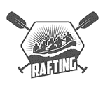

1. Four color label codes:

* Primary-color: #0B3954
* Secondary-color: #087E8B
* Accent1-color: #FF5A5F
* Accent2-color: #F2F2F2

1. Two font labels and the names of the fonts:

* Heading-font: Josefin Sans
* Text-font: Fira Sans

1. URL link to my color palette:

https://coolors.co/0b3954-087e8b-ff5a5f-f2f2f2